
COMPANY LOGO

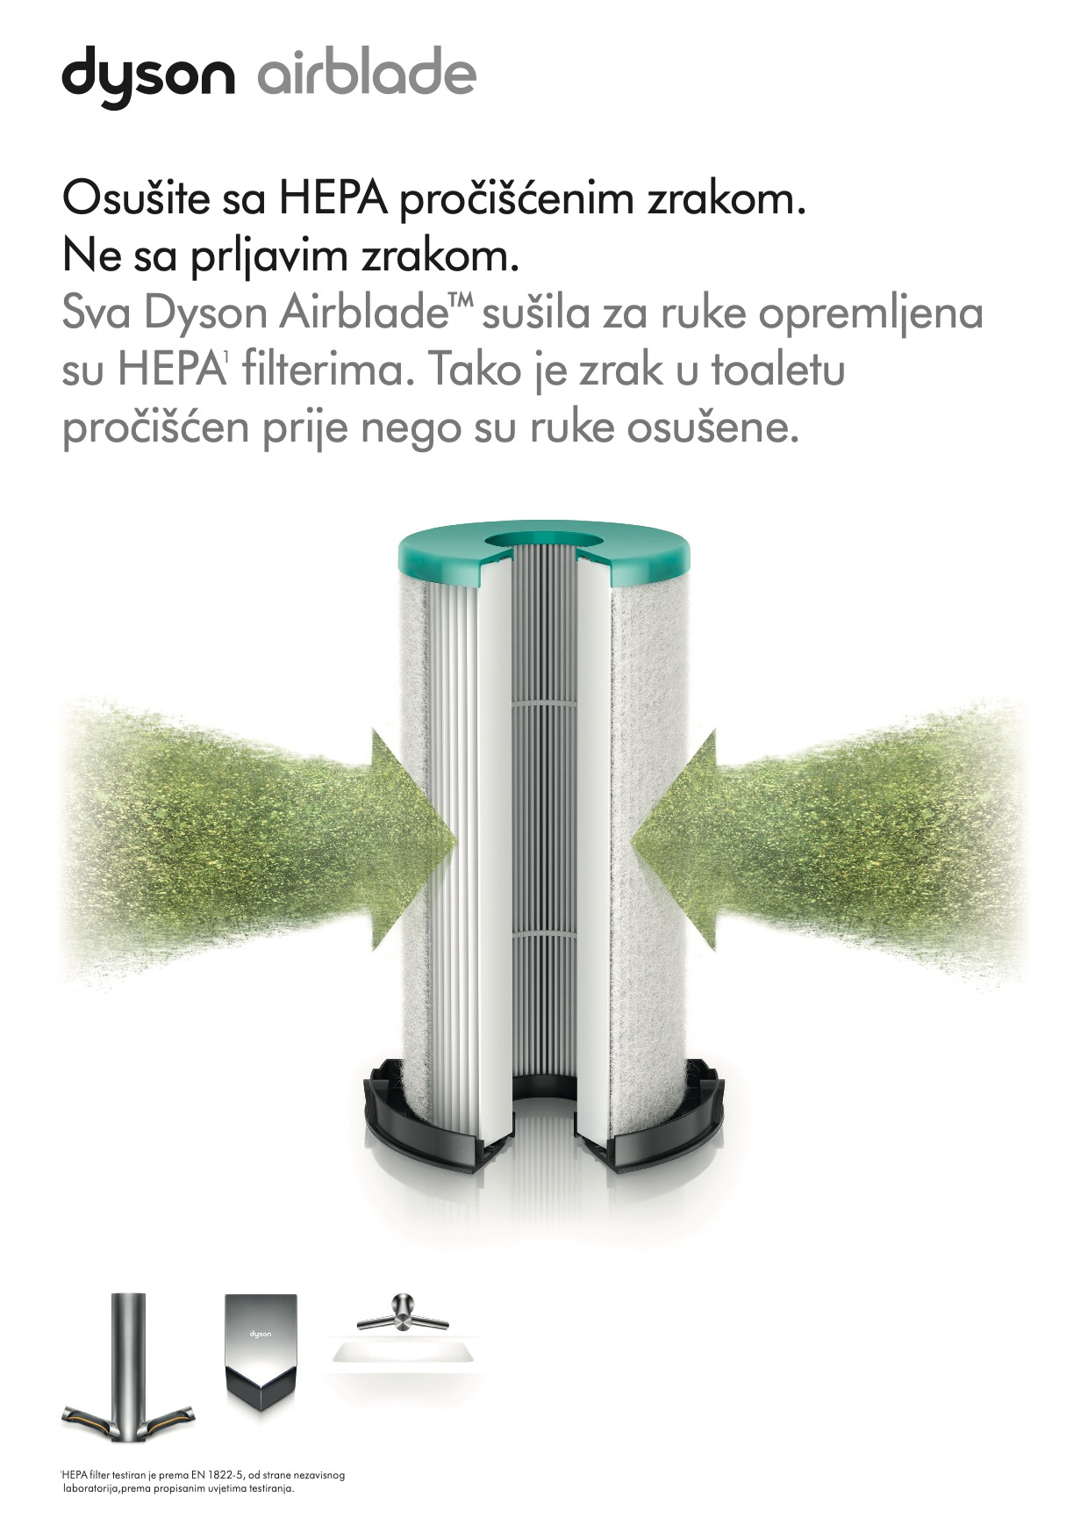
z
COMPANY LOGO
COMPANY LOGO
COMPANY LOGO
COMPANY LOGO
COMPANY LOGO

